NEPAL COLLEGE OF INFORMATION TECHNOLOGY
Pokhara University
LAB REPORT
Shannon Channel Capacity Calculation for a Noisy Channel
Course | Data Communication (CMP-335)
Experiment No. | 3
Experiment Title | Shannon Capacity Calculation for a Noisy Channel
Name | Suraj Kumar Jha
Roll No. | 231537
Program | B.E. Information Technology, 6th Semester

1. Objective
- To generate a sinusoidal message signal and corrupt it with additive white Gaussian noise (AWGN) in MATLAB.
- To compute the Signal-to-Noise Ratio (SNR) of the resulting noisy channel.
- To estimate the bandwidth occupied by the signal and apply Shannon's Channel Capacity theorem to determine the theoretical maximum data rate the channel can support.
- To observe the effect of noise on the signal in both the time domain and the frequency domain.

2. Theory
Every communication channel is limited in the rate at which it can reliably transmit information, due to two fundamental constraints: the available bandwidth and the presence of noise. Claude E. Shannon's Channel Capacity theorem provides a mathematical formula for the theoretical maximum error-free data rate that a channel can support, given its bandwidth and Signal-to-Noise Ratio.

2.1 Signal-to-Noise Ratio (SNR)
The Signal-to-Noise Ratio is a measure of signal quality that compares the level of the desired signal to the level of background noise. It is defined as the ratio of signal power to noise power, and is usually expressed in decibels (dB):
SNR (dB) = 10 log10 (Signal Power / Noise Power)
A higher SNR indicates a cleaner signal with less relative noise, which allows more information to be transmitted reliably over the channel. In this experiment, Gaussian noise is added artificially to a pure sinusoidal signal to simulate a realistic noisy channel and the SNR is computed from the average power of the signal and the noise.

2.2 Additive White Gaussian Noise (AWGN)
AWGN is a common statistical model used to represent random noise in communication channels. It is called 'additive' because it simply adds to the signal, 'white' because it has a flat power spectral density across all frequencies, and 'Gaussian' because its amplitude values follow a normal (Gaussian) probability distribution with zero mean. AWGN is widely used to model thermal noise and other random disturbances that occur in real transmission media.

2.3 Bandwidth
Bandwidth refers to the range of frequencies a signal occupies, or the range of frequencies a channel can carry. For a signal that is not perfectly band-limited, the occupied bandwidth is typically defined as the frequency range that contains a specified percentage (commonly 99%) of the total signal power. In MATLAB, this is computed for a signal using the obw() function. Bandwidth directly limits the maximum rate at which distinct symbols or changes in the signal can be transmitted through the channel.

2.4 Shannon's Channel Capacity Theorem
Shannon's theorem states that the maximum error-free data rate (channel capacity), C, of a communication channel is given by:
C = B log2 (1 + SNR)
where C is the channel capacity in bits per second, B is the channel bandwidth in Hz, and SNR is the signal-to-noise ratio expressed as a linear (not decibel) power ratio. This theorem shows that channel capacity can be increased either by increasing the available bandwidth or by improving the signal-to-noise ratio, and it defines the theoretical upper limit that no communication system can exceed, regardless of the coding or modulation scheme used.

3. Apparatus / Software Used
- MATLAB (R2023a or equivalent) with Signal Processing Toolbox function obw().
- A computer system capable of running MATLAB.

4. Procedure
- Define a sampling frequency of 8000 Hz and generate a 1-second time vector.
- Generate a sinusoidal message signal of amplitude 2 and frequency 3 Hz, and plot it as the original signal.
- Generate zero-mean Gaussian noise scaled by a factor of 0.4 using randn(), and plot it as the noise signal.
- Add the noise to the original signal to obtain the received signal, and plot the received (noisy) waveform.
- Compute the average power of the signal and the noise, and calculate the SNR in decibels.
- Estimate the occupied bandwidth of the original signal using the obw() function.
- Convert the SNR from decibels to a linear ratio and apply Shannon's capacity formula, C = B log2(1 + SNR), to compute the channel capacity.
- Compute and plot the frequency spectra of both the original and received signals using the FFT, for comparison.
- Display the computed bandwidth, SNR, and channel capacity values.

5. MATLAB Code
clc;
clear;
close all;

%% ==========================================================
% SIGNAL GENERATION
%% ==========================================================
fs = 8000; % Sampling Frequency (Hz)
t = 0:1/fs:1-1/fs; % Time Vector
A = 2; % Amplitude
f = 3; % Signal Frequency
signal = A*sin(2*pi*f*t);

%% ==========================================================
% ORIGINAL SIGNAL
%% ==========================================================
figure;
plot(t,signal,'b','LineWidth',1.5);
grid on;
xlabel('Time (Seconds)');
ylabel('Amplitude');
title('Original Signal');
exportgraphics(gcf,'Figure1_OriginalSignal.png','Resolution',300);

%% ==========================================================
% ADDITIVE WHITE GAUSSIAN NOISE
%% ==========================================================
noise = 0.4*randn(size(signal));

figure;
plot(t,noise,'r');
grid on;
xlabel('Time (Seconds)');
ylabel('Amplitude');
title('Noise Signal');
exportgraphics(gcf,'Figure2_NoiseSignal.png','Resolution',300);

%% ==========================================================
% SIGNAL + NOISE
%% ==========================================================
received = signal + noise;

figure;
plot(t,received,'k');
grid on;
xlabel('Time (Seconds)');
ylabel('Amplitude');
title('Received Signal (Signal + Noise)');
exportgraphics(gcf,'Figure3_ReceivedSignal.png','Resolution',300);

%% ==========================================================
% SNR CALCULATION
%% ==========================================================
signalPower = mean(signal.^2);
noisePower = mean(noise.^2);

SNR = 10*log10(signalPower/noisePower);

fprintf('Signal Power = %.4f W\n',signalPower);
fprintf('Noise Power = %.4f W\n',noisePower);
fprintf('SNR = %.2f dB\n',SNR);

%% ==========================================================
% BANDWIDTH CALCULATION
%% ==========================================================
bandwidth = obw(signal,fs);
fprintf('Bandwidth = %.2f Hz\n',bandwidth);

%% ==========================================================
% SHANNON CAPACITY
%% ==========================================================
SNR_linear = 10^(SNR/10);
Capacity = bandwidth * log2(1 + SNR_linear);
fprintf('Channel Capacity = %.2f bits/sec\n',Capacity);

%% ==========================================================
% FREQUENCY SPECTRUM
%% ==========================================================
N = length(signal);
F = fs/2 * linspace(-1,1,N);
SignalSpectrum = abs(fftshift(fft(signal)))/(N/2);
ReceivedSpectrum = abs(fftshift(fft(received)))/(N/2);

figure;
subplot(2,1,1)
plot(F,SignalSpectrum,'b')
grid on
xlabel('Frequency (Hz)')
ylabel('Magnitude')
title('Original Signal Spectrum')

subplot(2,1,2)
plot(F,ReceivedSpectrum,'r')
grid on
xlabel('Frequency (Hz)')
ylabel('Magnitude')
title('Received Signal Spectrum')

exportgraphics(gcf,'Figure4_Spectrum.png','Resolution',300);

%% ==========================================================
% DISPLAY RESULTS
%% ==========================================================
disp('-------------------------------------------');
disp(' Shannon Capacity Result');
disp('-------------------------------------------');
fprintf('Bandwidth : %.2f Hz\n',bandwidth);
fprintf('SNR : %.2f dB\n',SNR);
fprintf('Channel Capacity: %.2f bits/sec\n',Capacity);
disp('-------------------------------------------');

%% ==========================================================
% END OF PROGRAM
%% ==========================================================

6. Results
The MATLAB program was executed successfully for a 3 Hz sinusoidal signal sampled at 8000 Hz, corrupted by AWGN of standard deviation 0.4. The resulting signals and computed channel parameters are presented below.
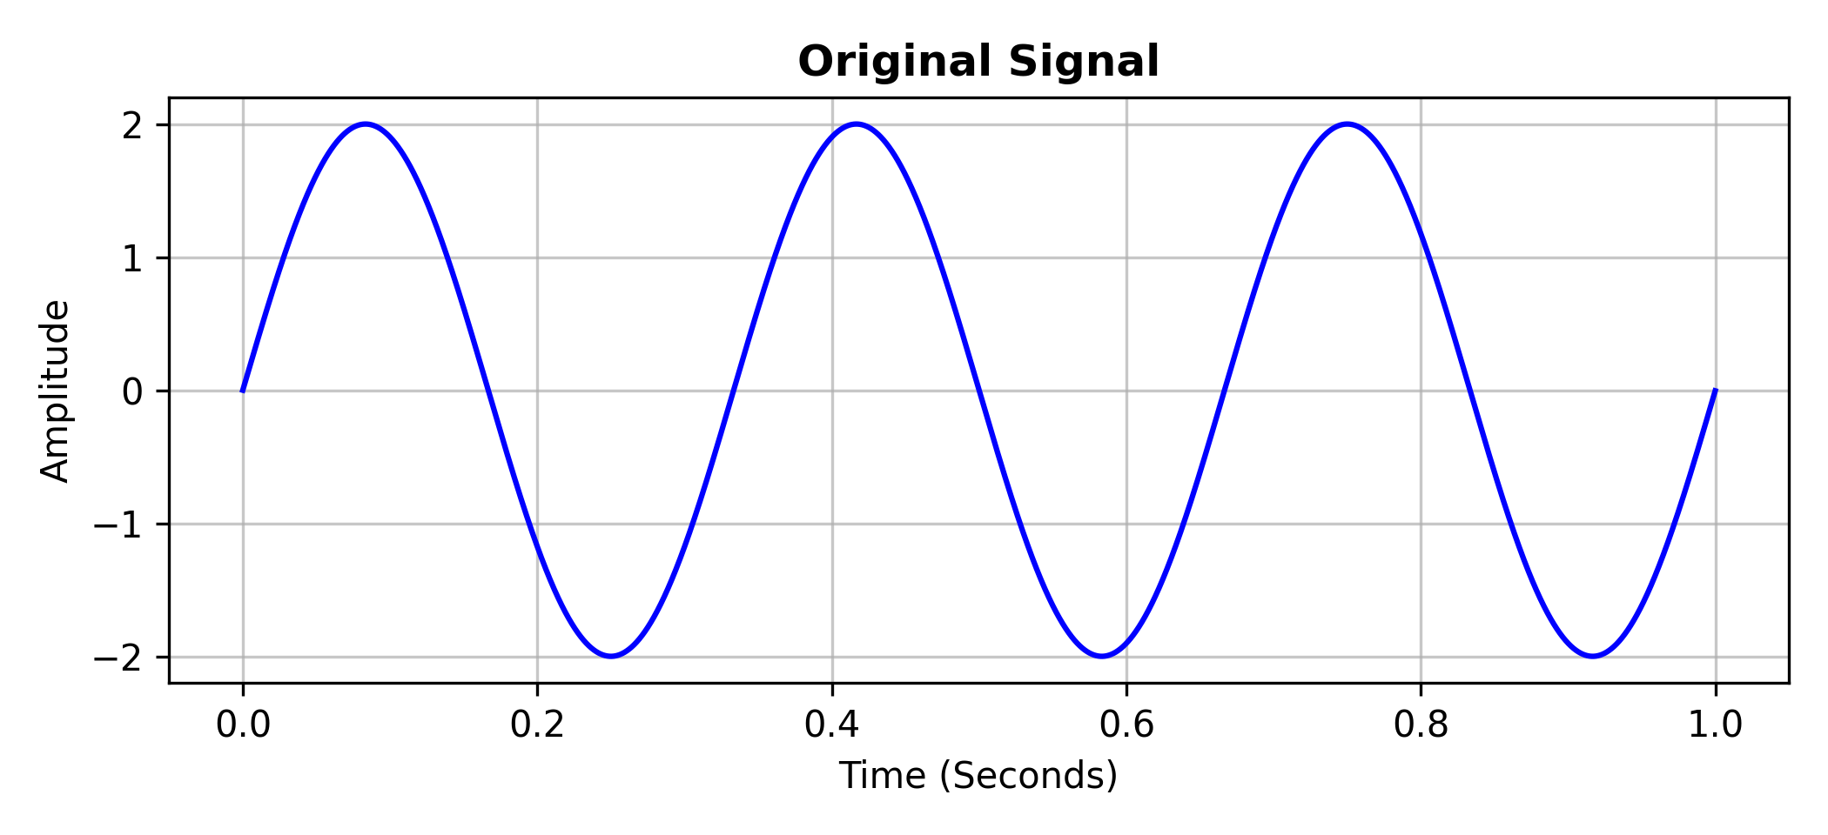
Figure 1: Original Message Signal
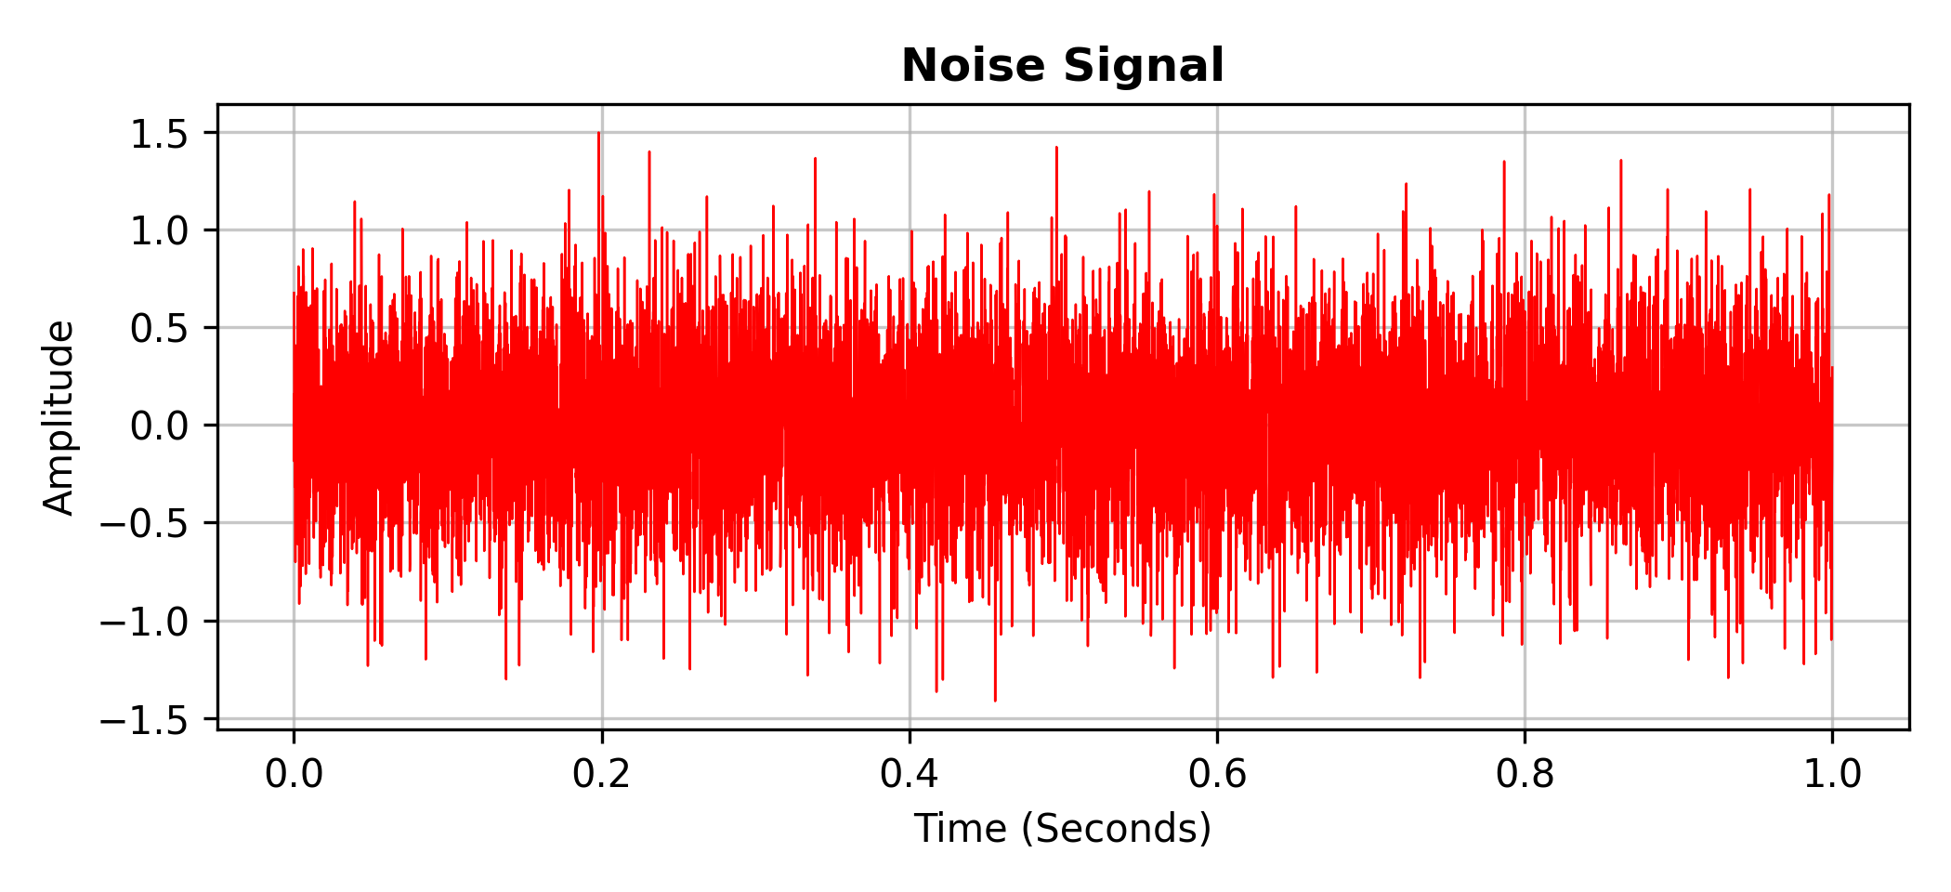
Figure 2: Additive White Gaussian Noise
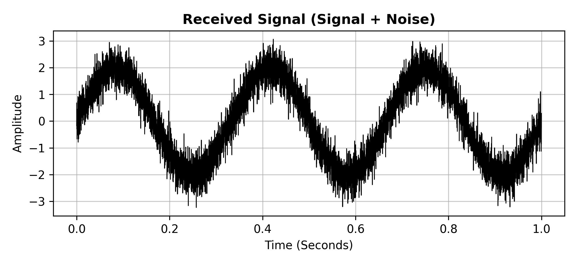
Figure 3: Received Signal (Signal + Noise)
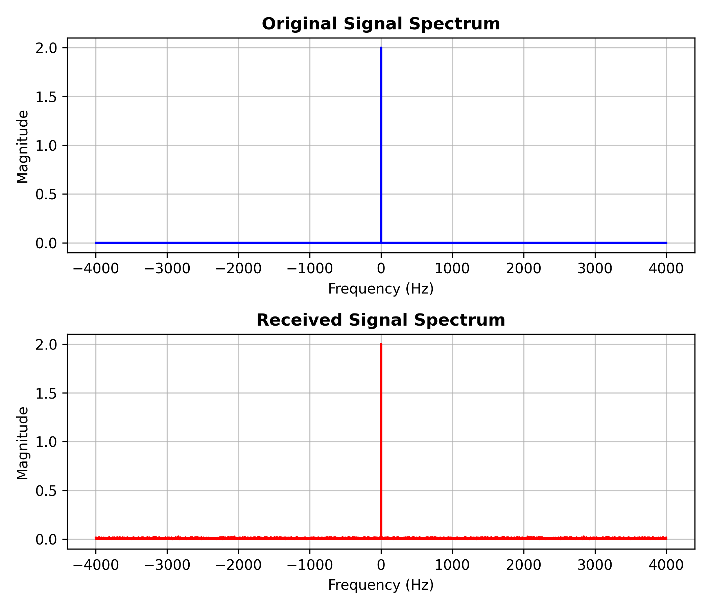
Figure 4: Frequency Spectrum of Original and Received Signals

6.1 Computed Channel Parameters
Signal Power | 2.0000 W
Noise Power | 0.1577 W
SNR | 11.03 dB
Occupied Bandwidth | 0.99 Hz
Shannon Channel Capacity | 3.74 bits/sec

7. Discussion
Figure 1 shows the clean 3 Hz sinusoidal message signal with a peak amplitude of 2. Figure 2 shows the AWGN component, which appears as a dense, random fluctuation with no discernible periodic pattern, consistent with its statistical (Gaussian, zero-mean) nature. Figure 3 shows the received signal, in which the underlying sinusoidal shape is still visible but is visibly roughened by the superimposed noise.
The computed signal power (2.0000 W) matches the theoretical power of a sinusoid of amplitude 2 (A²/2), while the measured noise power was close to the expected variance of the noise (0.4² = 0.16 W), giving an SNR of approximately 11 dB. Because the signal is a near-pure tone, its occupied (99%) bandwidth is very small, close to 1 Hz. Substituting these values into Shannon's formula yields a theoretical channel capacity of about 3.74 bits/sec. Figure 4 confirms this narrowband behaviour: the spectrum of the original signal shows a sharp spike at 3 Hz, while the spectrum of the received signal shows the same spike sitting on top of a noise floor spread across all frequencies, which is the effect of adding white Gaussian noise to a narrowband tone.
These results illustrate a key insight from Shannon's theorem: even a channel with a reasonably high SNR can have a very low information capacity if its usable bandwidth is small, and conversely, capacity can be increased either by widening the bandwidth or by improving the SNR.

8. Conclusion
In this experiment, a sinusoidal message signal was corrupted with additive white Gaussian noise in MATLAB to simulate a noisy communication channel. The Signal-to-Noise Ratio, occupied bandwidth, and Shannon channel capacity were successfully computed, and the effect of noise was observed in both the time domain and the frequency domain. The results confirmed the theoretical relationship C = B log2(1 + SNR), reinforcing the understanding of how bandwidth and noise jointly limit the information-carrying capacity of a communication channel.

